Name: Date: 03/07/17

Optimal Solution Project

Definition:
An optimal solution is a feasible solution (a region bounded by given constraints) where the objective function reaches its maximum (or minimum) value – for example, the most profit or the least cost.

Sample Problem:
A carpenter solely, makes tables and chairs, sells all tables and chairs to a local furniture store, however, does not have a stable income, and wishes to do his best. He wants to find out how many tables and chairs he should make to maximize net income. He calculated that production times required for a table and a chair are estimated to be 2 hours and 1 hour. Total labor hours per week are only 40 hrs. Raw materials required for a table and a chair are 1, and 2 units. Total supply of raw material is 50 units per week. He was also able to calculate the maximum profit function. Therefore:

Maximum 5 X + 3 Y
Constraints 2 X + Y < 40 (labor)
X+ 2 Y < 50 (material)
Keep in mind X and Y both are non-negative
Where X is the number of tables and Y is the number of chairs.

Using Desmos:
- Open up Desmos. This can be opened in any search engine.
https://www.desmos.com/calculator
- Click on the first line on the left to pop up the keyboard.
- On the first line type the first constraint (using the keyboard). You will see Desmos create a line with the proper shading at the right. 2 X + Y < 40
- Place the curser on the second line and type the second constraint. X+ 2 Y < 50
- On the right side of the screen you will see a “+” and “-“. Press the “-” three times to zoom out to see the first quadrant of the graph.
- Double tap on the extreme points (the points of intersection within the constraints, includes the point (0, 0)) by hovering of the points and clicking twice. These points give you the possible optimal solution.
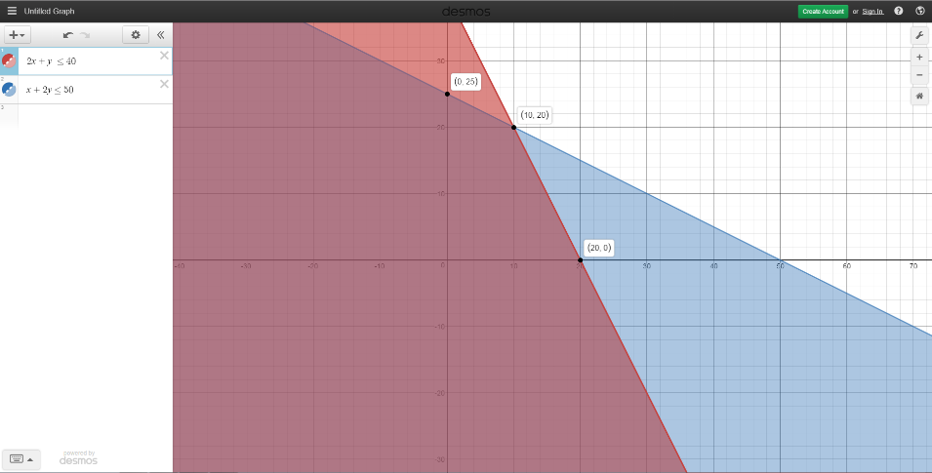
- Using the extreme points given calculate the possible maximum products.
- On lines 3 to 5 type the maximum profit formula and set the equation equal to each of the solutions found from step 7.
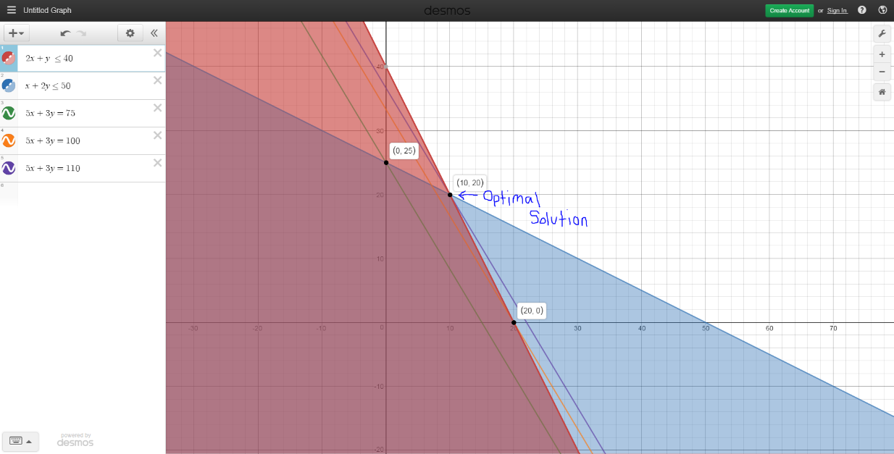
(The Optimal solution is the point that the max solution line hits last, it is the maximum amount of product that can be made to reach the maximum profit.)

Practice Problems:
- Find and graph the Optimal Solution of
2A+4B < 12
6A+4B < 24
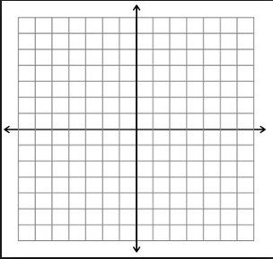

- Find and graph the Optimal Solution of

Min 8X+12Y
Constraint X+3Y > 9
2X+2Y > 10
6X+2Y > 18
X, Y > 0

